‘’Do not neglect the gift you have, which was conferred on you through the prophetic word with the imposition of hands of the presbyterate” (1Tim.4:14)

DEACONATE ORDINATION IN MBINGA DIOCESE
The Church is always happy when new ministers are ordained to carry on the work of evangelization. God tells us through Prophet Jeremiah that, “I will appoint over you shepherds after my own heart, who will shepherd you wisely and prudently”(Jer 3:15). God calls those whom He likes, not because of their worthiness but because of their unworthiness, so that He may reveal His power through them. It’s true that God calls those who are weak in order that they may not boast themselves. Commenting this, St.Paul the apostle says, “…Therefore, that I might not become too elated, a thorn in the flesh was given to me, an angel of Satan, to beat me, to keep me from being too elated. For when I am weak, then I am strong” (2Cor.12:7,10).
My dearest reader, on January 5th 2021, our Bishop Most. Rev. John Chrysostom Ndimbo, of Mbinga Diocese, ordained two Seminarians to deaconate, namely Deogratias Romanus Muli, from Kigonsera Parish, and Innocent Patrick Kihwili, from St.Alois Parish, respectively. It was a happy event in our Diocese, when it witnesses the availability of young men who are ready to serve the Church in clerical order. We convey our hearty thanks to the Almighty God for his gift of these two young men to our Diocese. We also thank our Bishop for receiving and raising the two to deaconate. May the Almighty God continue pouring his blessing to our Diocese Mbinga, and the Church at large.
In his homily, the Bishop advised and insisted them in order to become happy ministers in their life. Firstly, the Word of God, secondly obedience and humility, thirdly, personal and community prayer etc.
Bellow are some photos in various moments during the event:

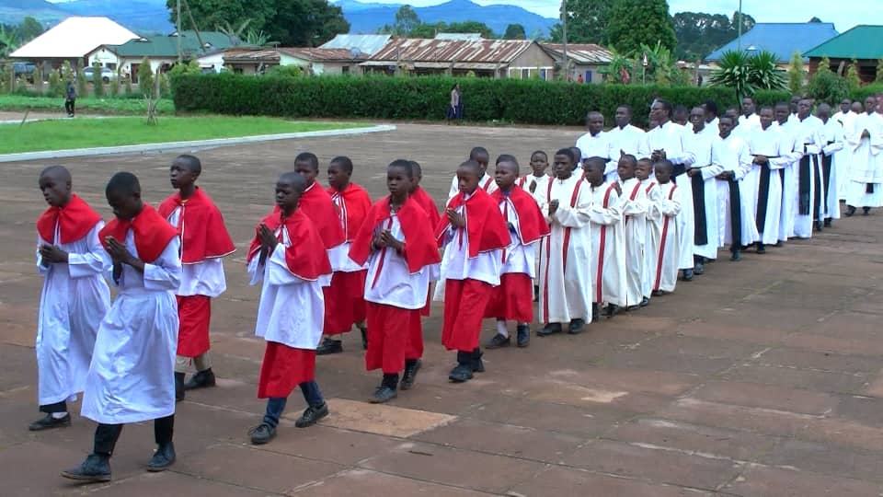
Procession to the Church
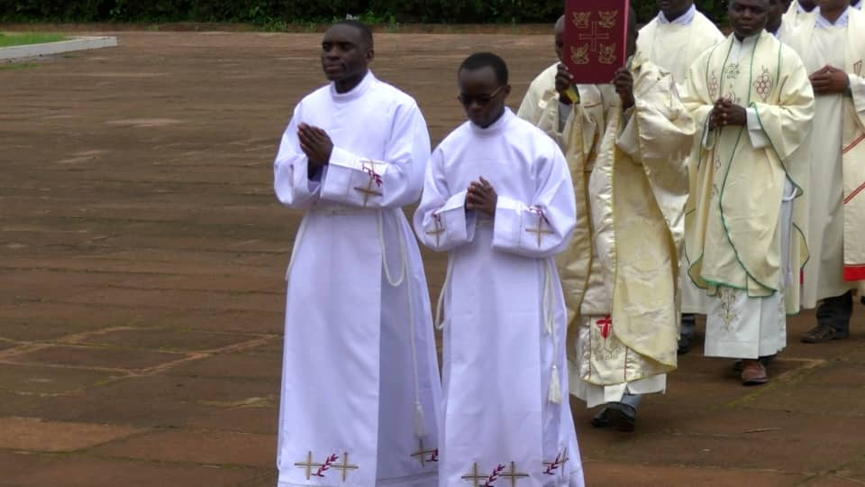
Two seminarians who were ordained deacons in procession
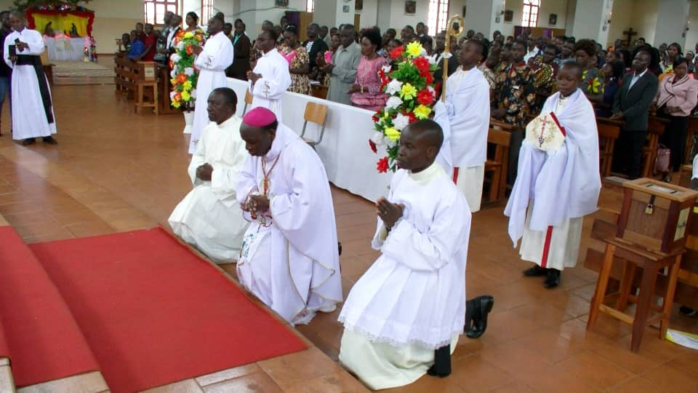
The Bishop in between, and Liturgist in his right hand and secretary in left, kneeling before the alter.

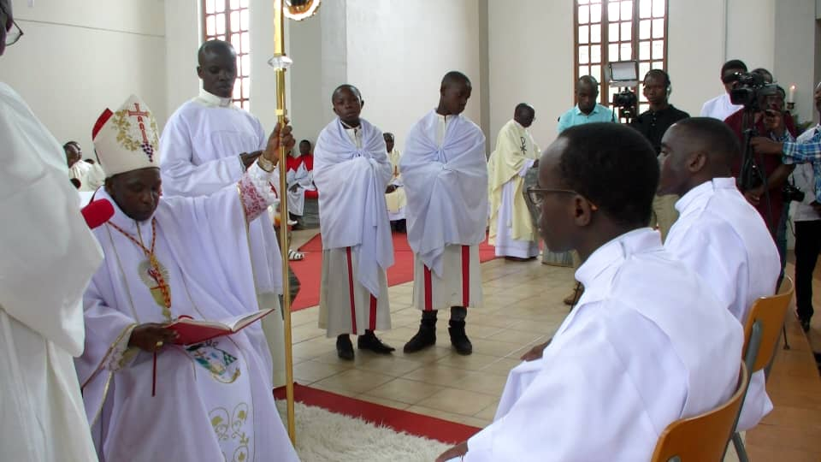
Homily from The Roman Pontifical to the two seminarians, before being ordained deacons
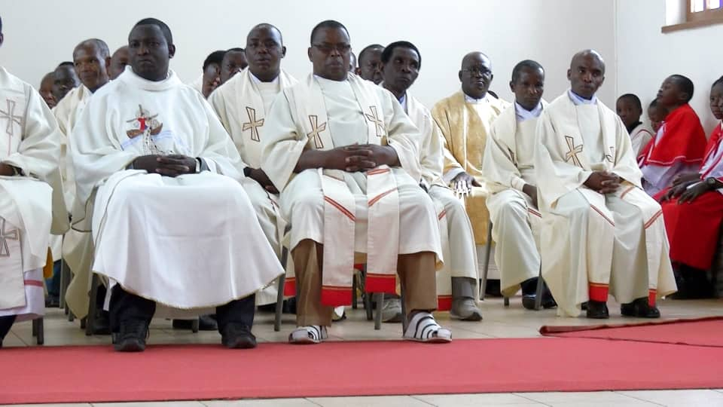
The above are among the priests who attended the event
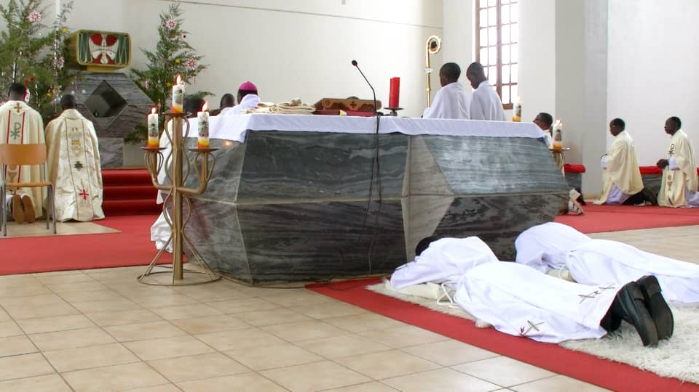
During the Litany, the two seminarians have fallen prostrate before the alter, as a sign of being ready to die for the Lord
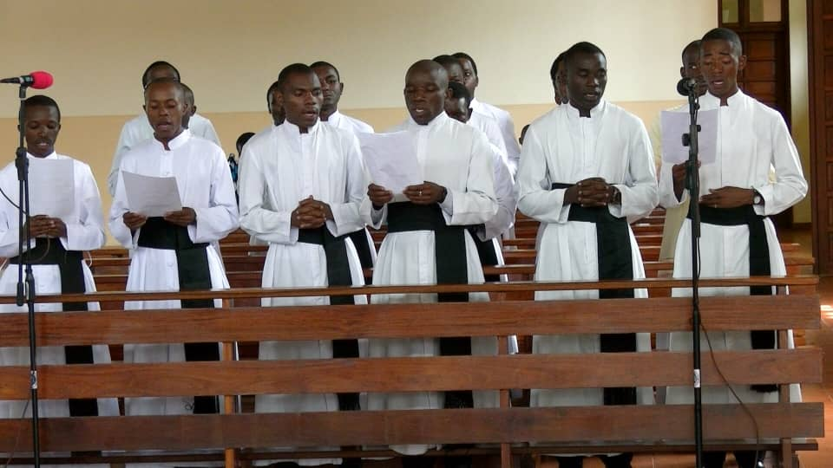
Here above are major seminarians, singing the Litany of the Saints.
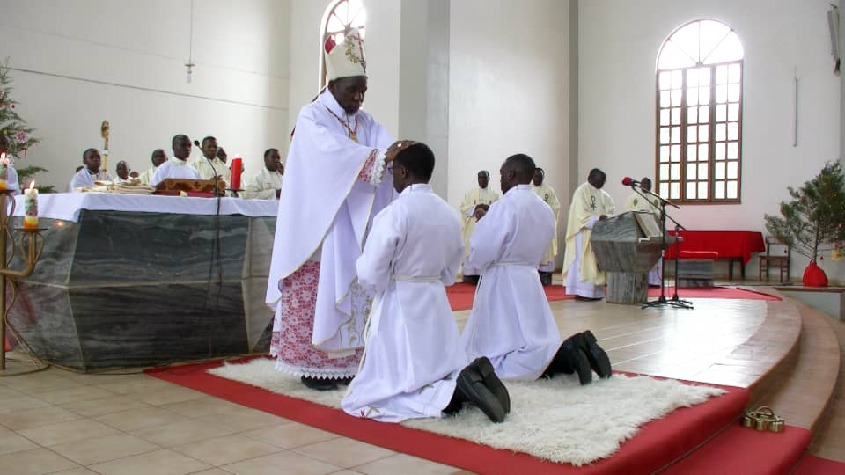
Ordination by imposition of hands
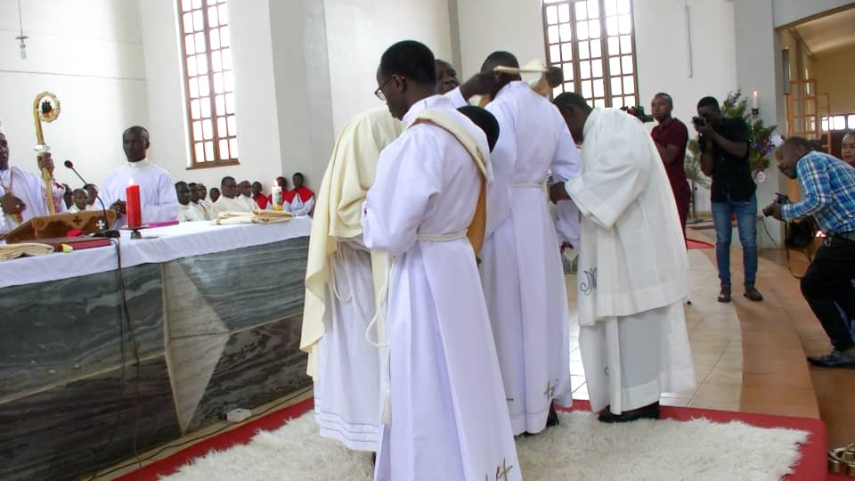
After ordination, the deacons were vested with their proper Liturgical vestments
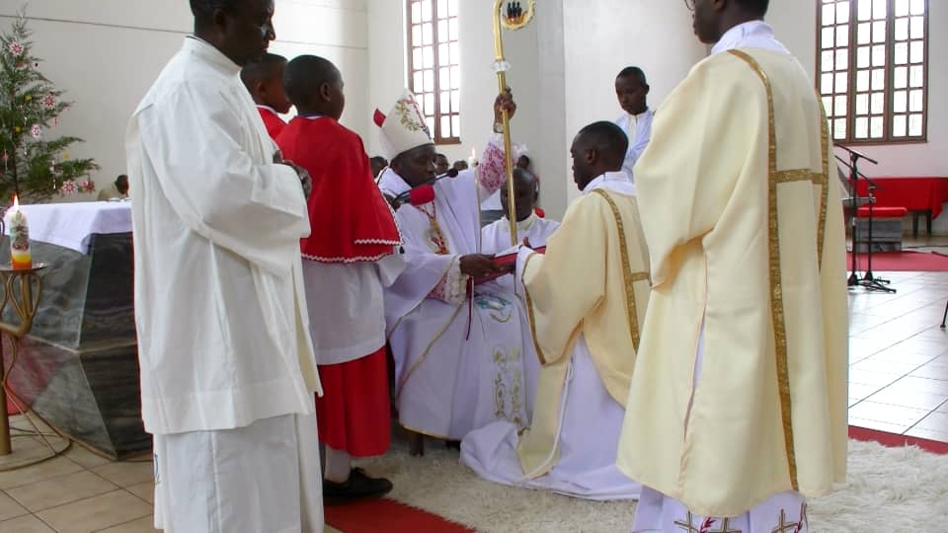
The event of ordaining deacons, goes together with handling them with Evangelium (The Book of Gospels)
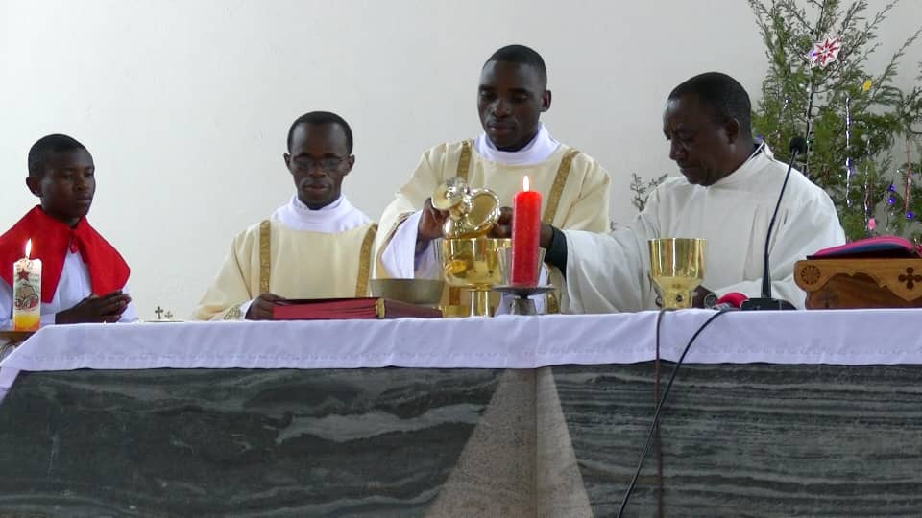
The two deacons at service on the alter
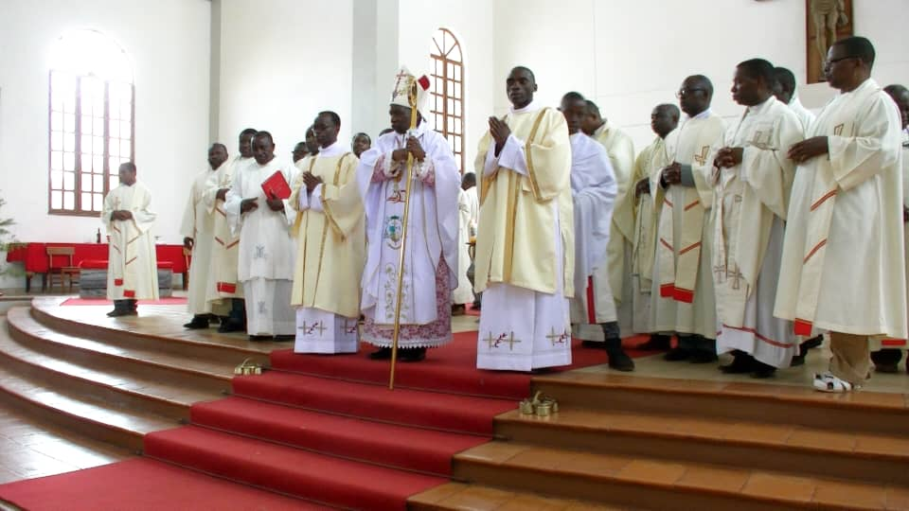
Lastly, they took some photos with various groups of
people who attended the ordination. The above are the Bishop, priests and deacons.
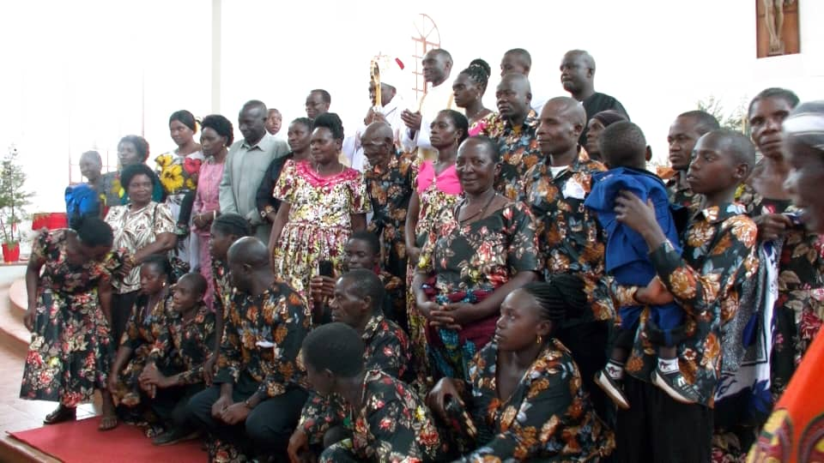
Then, the deacons took some photos with their family members

PRAYER FOR THE DEACONS AND OTHER MINISTERS
Heavenly Father, since the time of the Apostles You have inspired the Church to commission certain members to assist in a special way in the pastoral mission of Christ. Bless the deacons and all other ministers that they may be humble and faith-inspired in their service. We ask this through Christ our Lord. Amen.

TO GOD BE ALL GLORY AND PRAISE FOREVER AND EVER. AMEN.

